|  |  |  |  |  |  |
| --- | --- | --- | --- | --- | --- |
| Date | September 27, 2022 | | | Tester Name | Alyssa Johnson |
| Environment | Penfax - Test | | | Login used |  |
| Operating System | Select OS | Version: | Update: | | |
| Software Used | Select Software | Version: | Update: | | |
| Select Software | Version: | Update: | | |
| Release version | 22.3.0 | | | | |
| Title | E23.03 | | | | |
| Test Type | Regression | | | | |
| Test Scenario | Process Year End Batch (December Age 72 and above catchup withdrawal batch) | | | | |
|  |  | | | | |
| Expected Results | That batch will run & members will be paid their remaining minimum amount  Compare the amount is correct on several members that were paid in this batch in comparison to the Age 72 min report.  No regularly scheduled payments should be part of this batch? | | | | |
| Pass/Fail | Pass | | | JIRA# | N/A |

Step 1: Check the plan parameters to see when scheduled withdrawals should run:

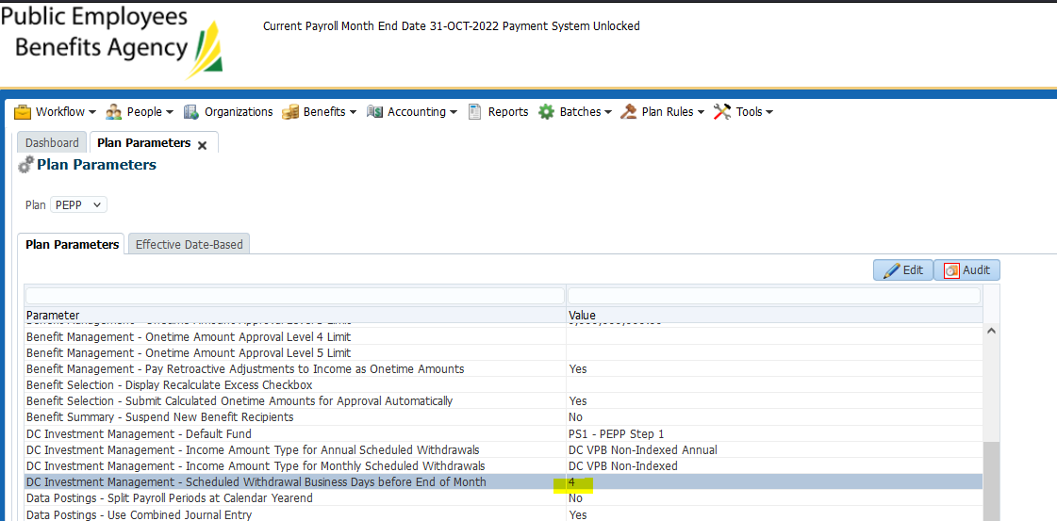

Use the date that is 4 business day’s before the end of the month (for December of the current year in next step):

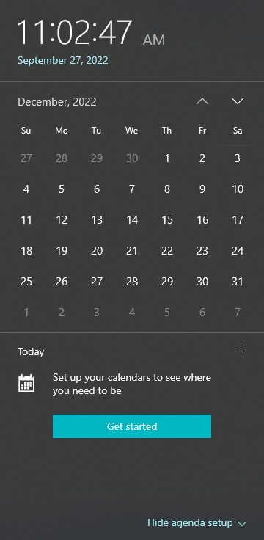

Business days = 27,28,29,30 (none of those days are stats or blackout days)

Declare unit values for Dec 27, 2022:

Process Investment Transactions:

